`

Student Name | SUGGESTED SOLUTIONS
Teacher | GSL | MDI | HAL | SMH

CHEMISTRY
Unit 3, SAC 2
Test on concepts from Chapters 7-8 of Heinemann Chemistry 2
Rate and extent of chemical reactions

1st June 2020, Period 4
Reading time: 5 minutes
Writing time: 60 minutes

Structure of Report
Task and Section | Number of questions | Number of questions to be answered | Number of marks
Section A Multiple Choice Questions | 10 | 10 | 10
Section B Short Answer Questions | 6 | 6 | 36
 |  |  | Total 46

- Students are permitted to bring into the assessment room: pens, pencils, highlighters, erasers, sharpeners, rulers and one scientific calculator.
- Students are not permitted to bring into the examination room: blank sheets of paper and/or white out liquid/tape.
Materials supplied
- This question and answer book of 12 pages.
- A data book
Instructions
- Write your name in the space provided above on this page.
- All responses must be written in English.
- Working out must be shown for all calculations
- Do NOT write on the data book
At the end of the assessment session
- Wait silently for the supervisor to collect your booklet and data book.
Students are NOT permitted to bring mobile phones and/or any other unauthorised electronic devices into the examination room.
Students must not disclose the contents of the task; to do so will be a breach of VCE guidelines and will be dealt with according to VCAA regulations.

SECTION A: Test Multiple-Choice Questions

Instructions for Section A
Answer all questions in pencil on the answer sheet provided for multiple choice questions.
Choose the response that is correct or that best answers the question.
A correct answer scores 1, an incorrect answer scores 0.
Marks will not be deducted for incorrect answers.
No marks will be given if more than one answer is completed for any question.

Question 1
Which statement is correct as the temperature for a sample of a gas, X, increases?

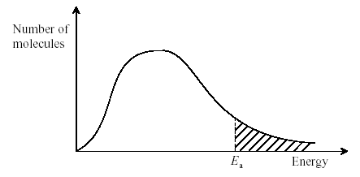
Energy
E_{a}
Number of molecules

A. The area under the curve to the left of Ea decreases.
B. The total area under the curve increases.
C. The activation energy decreases.
D. More molecules have the mean energy.

Answer: A

A. True: A temperature increase, causes the average kinetic energy of the particles to increase and shifts the graph to the right, so there are more particles with energies equal to or greater than the activation energy.
B. False: The total area under the curve, which is equal to the total number of particles in a sample stays constant when the temperature is changed.
C. False: The activation energy of a reaction does not change due to a change in temperature.
D. False: This statement is broad. We need to refer to the energy as the average kinetic energy of the particles.

Question 2
Reaction rates generally increase with an increase in temperature. Four suggested reasons are:

- Molecules collide more frequently at higher temperatures.
- As the temperature of a reaction increases, the activation energy for the reaction decreases.
- The concentration of reactants will be greater at a higher temperature.
- The fraction of high energy molecules is greater at higher temperatures.

The correct statements are:
- II and IV only
- I and IV only
C. I, II and IV only
D. I, III, and IV only

Correct answer: B

- Molecules collide more frequently at higher temperatures.
True according to the collision theory
- As the temperature of a reaction increases, the activation energy for the reaction decreases.
False: The activation energy is not affected by temperature. Only catalysts lower the activation energy by providing an alternative pathway for the reaction to proceed
- The concentration of reactants will be greater at a higher temperature.
False: In a system the concentration will not increase by an increase in temperature
- The fraction of high energy molecules is greater at higher temperatures.
True: At a higher temperature the average kinetic energy of molecules increases and therefore there is a higher fraction of molecules travelling faster.

Question 3
It is generally believed that catalysts increase reaction rates by:

A. removing the activation energy barrier and lowering the change in enthalpy, ∆H.
B. providing an alternate activation energy barrier that is lower than the original activation energy barrier.
C. lowering the activation energy barrier and increasing the change in enthalpy, ∆H.
D. giving the reacting particles more energy, thus there will be more successful collisions

Answer: B
Catalysts provide an alternative reaction pathway by lowering the activation energy barrier of a particular reaction.
Catalysts do not change the change in enthalpy, ∆H.

Question 4
If the reaction quotient Q has a smaller value than the related equilibrium constant, K

A. the reaction is at equilibrium.
B. the reaction is not at equilibrium, and will make more products at the expense of reactants.
C. the reaction is not at equilibrium, and will make more reactants at the expense of products.
D. the value of K will decrease until it is equal to Q

Answer: B
Since Q<K, the reaction shifts to the right towards the products to increase Q and reach equilibrium

Question 5
If 0.10 mol of gas A and 0.10 mol of gas B are initially added to a 1L container, which of the following must be true once the mixture achieves equilibrium?

A + 2B $⇌$ 2C K_{c} = 320 M⁻¹
- [A] = [B]
- [B] = 2[C]
- [A] < [B]
- [A] > [B]

Answer: D
Limiting Working:
n(A) = ½ x n(B)
= ½ x 0.10
=0.05 mol
A-limiting reactant
B-excess
 | A + | 2B $⇌$ | 2C
I | 0.10 mol | 0.10 mol | 0 mol
C | 0.05 mol | 0.10 mol | 0.10 mol
E | 0.05 mol  C= 0.051 = 0.05M | 0 mol  C = 01 = 0M | 0.10 mol  C= 0.101 = 0.10M

From these calculations, we can see that the answer must be D, since [A] > [B]

Question 6
The equilibrium constant for the formation of sulphur trioxide from sulphur dioxide and oxygen gas is 4.3 M⁻¹ according to the reaction:

2SO₂(g) + O₂ (g) $⇌$ 2SO₃ (g) K_{c} = 4.3 M⁻¹

What is the value of the equilibrium constant for the reverse of this reaction?

- –4.3
- –0.23
- 0.23
- 0.43

Answer: C

K_{c} = 14.3 = 0.23

Question 7
Nitrogen dioxide, NO₂ (a brown gas) and dinitrogen tetroxide, N₂O₄ (a colourless gas) are in equilibrium according to the equation
2NO₂(g) $⇌$ N₂O₄(g)

An equilibrium mixture of the two gases at room temperature is light brown but at higher temperatures the colour becomes a much deeper brown. What conclusion can be drawn from this observation?

A. The reverse reaction in the equation is endothermic.
B. The forward reaction in the equation is endothermic.
C. The brown colour is due to the strong nitrogen–oxygen bonds in NO₂.
D. The equilibrium concentration of N₂O₄ is not dependent on temperature.

Answer: A
Since increasing the temperature favours the reverse reaction, then the reverse reaction must be an endothermic reaction and the forward reaction must be exothermic.

Question 8
Three gases X, Y and Z were mixed in a closed container and allowed to reach equilibrium. A change was imposed at time T and the equilibrium was re-established. The concentration of each gas is plotted against time.

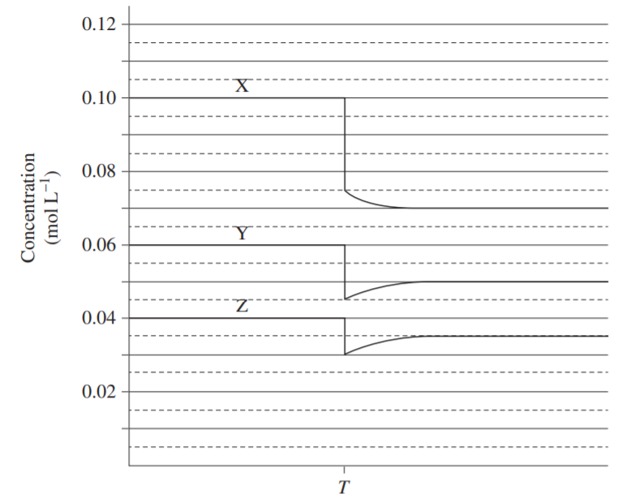
T
Concentration (mol L⁻¹)

Which reaction does the graph represent?
A. X(g) + Y(g) $⇌$ 2Z(g)
B. 2X(g) $⇌$ Y(g) + Z(g)
C. 2X(g) $⇌$ Y(g) + 3Z(g)
D. X(g) $⇌$ Y(g) + Z(g)

Answer: D

At time T, the concentration for all of the species has dropped which is due to an increase in volume and therefore a decrease in pressure. According to Le Chatelier’s Principle the system will oppose the change to the pressure by increasing the pressure and in this case favour the reaction which increases the number of particles.
Therefore we can eliminate A and B. We can also see that with C, that the ratios in the equation are not reflected by those shown on the graph.

We can also see from the graph that the ratio for each of the species must be 1:1:1 and therefore the answer must be D.

Question 9
Consider the following reaction:

N₂ (g) + O₂(g) $⇌$ 2NO(g) ∆H = +176 kJ mol⁻¹

An increase in temperature would:

- Shift the equilibrium in favour of the reverse reaction and increase the value of K.
- Shift the equilibrium in favour of the forward reaction and decrease the value of K.
- Shift the equilibrium in favour of the forward reaction and increase the value of K.
- Cause no change to the system.

Answer: C
An increase in temperature would favour the forward reaction since it is an endothermic reaction. This would lead to a higher concentration of the products and since K =$\frac{[products]}{[reactants]}$ the value of K would increase.

Question 10

Ammonia, ( NH₃ ) is produced during the Haber Process and it is in equilibrium with nitrogen,( N₂ ) and hydrogen gas, ( H₂ ).

N₂ (g) + 3H₂(g) $⇌$ 2NH₃(g) ∆H = -91 kJ mol⁻¹

Which change would improve the yield of NH₃(g) at equilibrium?

A. increase the temperature
B. use a catalyst
C. decrease the volume
D. add large amounts of argon gas

Answer : C

- False.
As the forward reaction is an exothermic reaction, increasing the temperature will favour the reverse reaction which is endothermic. Therefore, this would increase the concentration of the reactants and not improve the yield of ammonia.
- Using a catalyst will provide an alternative pathway with a lower activation energy so the reaction will proceed at a faster rate
- True
A decrease in volume would result in an increase in pressure.
According to Le Chatelier’s Principle, the system will oppose the change to an increase in pressure by favouring the side which reduces the number of particles and in this case it would be the forward reaction. Therefore, there is a net shift to the right and the yield of ammonia would be improved.
- False
Adding large amounts of the inert gas argon would not affect the equilibrium of the gases in the system (N₂ (g)+ 3H₂(g) $⇌$2NH₃(g)). The total pressure of the system would increase but there is no change to the concentrations of the reactants or products.

End of Section A

Section A: Multiple Choice Answer Sheet
This answer sheet must not be detached from this booklet.

INSTRUCTIONS FOR MULTIPLE CHOICE ANSWER SHEET
Use a PENCIL for ALL entries. For each question, shade the box which indicates your answer.
Marks will NOT be deducted for incorrect answers.
NO MARK will be given if more than one answer is completed for any question.
If you make a mistake, ERASE the incorrect answer - DO NOT cross it out.

1 |  | A |  | B |  | C |  | D
2 |  | A |  | B |  | C |  | D
3 |  | A |  | B |  | C |  | D
4 |  | A |  | B |  | C |  | D
5 |  | A |  | B |  | C |  | D
6 |  | A |  | B |  | C |  | D
7 |  | A |  | B |  | C |  | D
8 |  | A |  | B |  | C |  | D
9 |  | A |  | B |  | C |  | D
10 |  | A |  | B |  | C |  | D

SECTION B Test Short Answer Questions

Instructions for Section B
Answer all questions in the spaces provided. Write using black or blue pen.
To obtain full marks for your responses you should:
- Give simplified answers with an appropriate number of significant figures to all numerical questions; un-simplified answers will not be given full marks.
- Show all working in your answers to numerical questions. No marks will be given for an incorrect answer unless it is accompanied by details of the working.
- Make sure chemical equations are balanced and that the formulas for individual substances include an indication of state; for example, H₂(g); NaCl(s)

Question 1 (4 marks)
For the following reaction, write how each of the changes will affect the indicated quantity, assuming a container of fixed size.
Write “increase”, “decrease”, or “no change”.
For a chemical added, write how it would respond AFTER the initial spike due to the addition.
H₂(g) + Br₂(g) $⇌$ 2HBr(g) ΔH = -103.7kJ mol⁻¹

Change | [H₂] | [Br₂] | [HBr] | K value
H₂ added
HBr added
The temperature is increased
Pressure is increased

Solution:
Change | [H₂] | [Br₂] | [HBr] | K value
H₂ added | decrease | decrease | increase | No change
HBr added | increase | increase | decrease | No change
The temperature is increased | increase | increase | decrease | Decrease  K=$\frac{[products]}{[reactants]}$
Pressure is increased | No change | No change | No change | No change

(1 mark for each row fully correct) x 4 = 4 marks

Question 2 (10 marks)
Hydrogen peroxide is a mild antiseptic which can decompose according to the equation:
catalyst
2H₂O₂ (aq) → 2H₂O (l) + O₂ (g)

- Referring to the Collision Theory, explain the role of the catalyst in the decomposition of hydrogen peroxide.
(2 marks)

A catalyst is a substance which speeds up the rate of a reaction but is not consumed by the reaction.
A catalyst lowers the activation energy of a reaction by providing an alternative pathway, with lower E_{a}, for the reaction. (1 mark for both parts)

At this lower activation energy, the colliding particles are more likely to have energies that exceed this lower barrier, causing the bonds in the reactants to be broken more frequently. Therefore, a higher proportion of collisions are ‘successful’ which lead to the formation of the new products. Therefore, the rate of reaction is increased. (1 mark)

An experiment was set up to investigate the decomposition of 1.0L of hydrogen peroxide solution at two different temperatures, one at SLC and the other at a higher temperature using the set up shown below:

Gas syringe
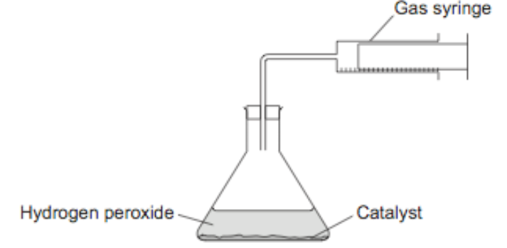
Hydrogen peroxide
Catalyst

A graph was drawn to represent the information at these two temperatures.
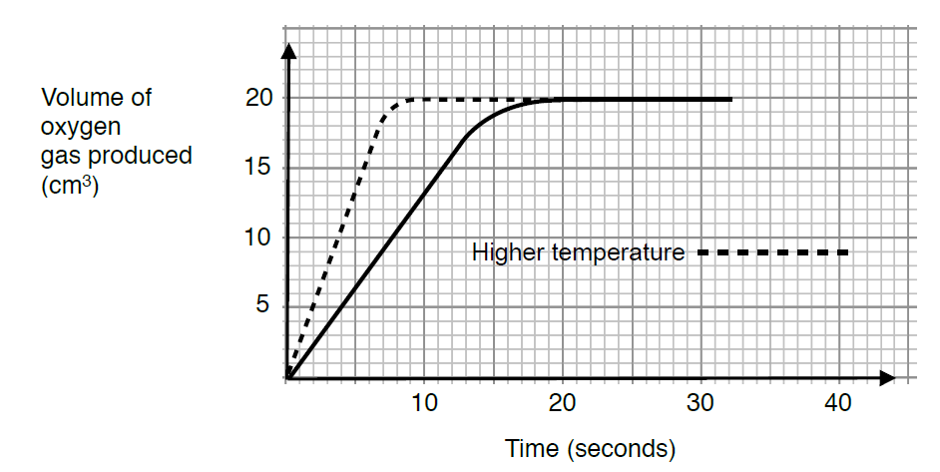

(mL)

- Use the Collision Theory to explain the shape of the graph for the higher temperature.
(3 marks)

As the temperature of a reaction increases so too does the rate of reaction as can be seen by the steeper shape of the graph at the higher temperature in the first 10 seconds (approx). (1 mark)

Increasing the temperature, increases the average kinetic energy (accept higher/faster speed/move faster) of the particles which in turn increases the frequency of successful collisions which would have occurred at the lower temperature.
(1 mark).

More particles would have the minimum energy required to overcome the activation energy and so the proportion of successful collisions would increase and hence the rate of the reaction would also increase. (1 mark)

- Explain why both of the graphs eventually level off and become horizontal to the x axis.
(1 mark)

H₂O₂ has completely decomposed or is used up. (1mark)

d. i. Calculate the amount, in mol of the oxygen gas produced by the decomposition of the hydrogen peroxide, H₂O₂ at the lower temperature. (1 mark)

Since , we are told that one of the temperatures was at SLC (the lower temperature),

V(O₂) = n x 24.8
20.0 mL(from graph) = n x 24.8
n(O₂) = (20.0 x 10⁻³) /24.8
= 8.0645 x10 ⁻⁴
= 8.10 x10 ⁻⁴ mol 1 mark (units not required)

- Calculate the concentration of the hydrogen peroxide in % m/v. (3 marks)

Mark this question consequentially
O₂ : H₂O₂
1 : 2

n(H₂O₂) = 2 x n(O₂ )
= 2 x 8.10x10 ⁻⁴ mol
= 1.60 x10 ⁻³ mol 1 mark

C H2O2 = nV
C= 1.6 x10-3 mol1
= $1.6 x{10}^{-3}$mol/L 1 mark here or 1 mark for the calculation of the mass (H₂O₂)

This means: $1.6 x{10}^{-3}$mol per 1000 mL
m(H₂O₂) = n x M
= $1.6 x{10}^{-3}$mol x 34
= 0.0548
= 0.055 g

0.055 g in 1000mL
X g in 100 mL
By proportions: x = (0.055 x 100)/1000
=0.0055% w/v 1 mark (units not required)

Question 3 (3 marks)

Explain, in terms of particles, why the rate of non-equilibrium reactions decrease over time.

In non-equilibrium reactions, all reactants form products or there is only a forward reaction. (1 mark)

The rate of reaction is defined as the change in concentration of a reactant or product per unit of time.

As the reaction proceeds the reactants are converted into the products (or are used up) and there are fewer particles to react (or a lower concentration of particles.)

This results is a lower frequency of successful collisions, (1 mark) so there are fewer particles reacting in a given time. 1mark

Question 4 (6 marks)

An industrial plant makes ammonia from nitrogen gas and hydrogen gas. The reaction is exothermic. The graph, not drawn to scale, shows the adjustments made to increase the production of ammonia.

N₂(g) + 3H₂(g) $⇌$ 2NH₃(g) ∆H = –92 kJ mol^{–1}

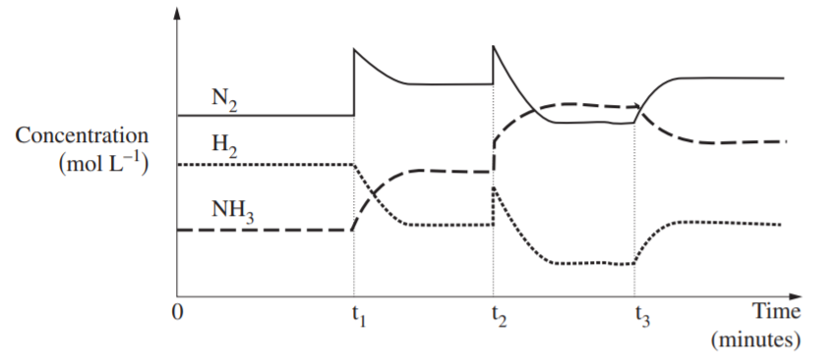

- Complete the table to identify what possible changes occurred at times t₁, t₂ and t₃. (3 marks)

Time | Cause for change
t₁ | Addition of N₂(g) (state not required)
t₂ | decrease in volume of the reaction vessel which will produce an increase in pressure on the system
t₃ | Increase in temperature

- Use Le Chatelier’s Principle to explain the cause for the change in the graph at one of the times.(t₁ or t₂)

State the section of the graph, t₁ or t₂ you will use to explain the change in your answer.
(2 marks)
Section of graph:

Explanation:

Time | Cause for change in concentration | Explanation
t₁ | Addition of N2(g) | According to Le Chatelier’s principle, when a system at equilibrium is disturbed, the equilibrium will shift in the direction to partially oppose the change to decrease the concentration of N₂. So the equilibrium will net shift to the right (forward reaction) to use up more nitrogen which will produce a greater yield of ammonia until equilibrium is re-established.
t₂ | decrease in volume of the reaction vessel which will produce an increase in pressure on the system. | In the above equation, it can be seen that there are 4 moles of gas on the left-hand side of the equation and 2 moles of gas on the right-hand side. An increase in pressure will cause the system to shift to partially oppose the change and thus move to the side with fewer moles of gas to reduce pressure. This increases the yield of ammonia as the forward reaction (net shift to the right) is favoured until equilibrium is re-established.
t₃ | Increase in temperature | At t3 there is a change to the system that favours the reverse reaction. As the concentration of reactants and products does not change suddenly, this is most likely to be due to a change in temperature. As this reaction is exothermic, an increase in temperature is likely to have occurred which will favour the reaction that absorbs heat, the endothermic reaction. Thus the reverse reaction (net shift to the left) is favoured, lowering the yield of ammonia until equilibrium is re-established.

- Would the temperature of the mixture increase, decrease or remain the same between t₂ and t₃? Explain your reasoning. (1 mark)

The reaction mixture would increase as the change at t2 would favour the forward reaction which is an exothermic reaction in this case. (1 mark)

The reaction mixture would increase as the change at t2 would favour the forward reaction which is an exothermic reaction in this case. (1 mark)
With an exothermic reaction the total energy of the products is less than the total chemical energy of the reactants, the excess energy is released to the surroundings. ( 1mark)
The reaction mixture would increase as the change at t2 would favour the forward reaction which is an exothermic reaction in this case. (1 mark)
With an exothermic reaction the total energy of the products is less than the total chemical energy of the reactants, the excess energy is released to the surroundings. ( 1mark)

Question 5 (9 marks)

Phosphoryl chloride, (POCl₃) is manufactured industrially on a large scale from phosphorus trichloride, (PCl₃ ) and oxygen according to the reaction:

2PCl₃(g) + O₂ (g) $⇌$ 2POCl₃ (g) ∆H = −560 kJ mol⁻¹

The change in concentration of phosphoryl chloride with time when only PCl₃ gas and O₂ gas are present initially in a 1.0 L sealed container at 400⁰C is shown below:

POCl₃
(mol L⁻¹)

0.14

0.12
0.02
0.04
0.088
0.06
0.10
Time

A

B

- Write the equilibrium expression for the reaction, include units. (2 marks)

K_{c} = $\frac{{[{POCl}_{3}]}^{2}}{[{{PCl}_{3}]}^{2}[O_{2}]}$ 1 mark – no units required

K_{c} = $\frac{{[{POCl}_{3}]}^{2}}{[{{PCl}_{3}]}^{2}[O_{2}]}$ M⁻¹ 1 mark for the expression
1 mark for the unit

- At 400⁰C the reaction quotient for the reaction at point A is 1.2 x 10³ M⁻¹ and the concentration of PCl₃ is 0.030 mol L⁻¹. Calculate the concentration of O₂ at point A.
(2 marks)

K_{c} = $\frac{{[{POCl}_{3}]}^{2}}{[{{PCl}_{3}]}^{2}[O_{2}]}$ from the graph [${POCl}_{3}]=0.03$ mol L⁻¹ (1 mark)

1.2 x 10³ = $\frac{{(0.03)}^{2}}{({0.03)}^{2 } × [O_{2}]}$

$[O_{2}]$ = 8.34 x 10⁻⁴ M 1 mark (must include units)

- i. Use Le Chatelier’s Principle to explain whether the temperature was increased or decreased at point B. (2 marks)

According to Le Chatelier’s principle, when a system at equilibrium is disturbed, the equilibrium will shift in the direction to partially oppose the change. As this reaction is exothermic, a decrease in temperature (1 mark) is likely to have occurred at Point B which will favour the forward reaction (net shift to the right), increasing the yield of POCl₃ until equilibrium is re-established. (1 mark)

- Use the equilibrium expression from part a. to explain the effect that the temperature would have on the equilibrium constant, K_{c} at Point B. (2 marks)

The value of the equilibrium constant, K_{c} would increase with the decrease in temperature as the concentration of the product POCl₃ would increase and therefore the concentration fraction would increase.
K_{c} = $\frac{{[{POCl}_{3}]}^{2}}{[{{PCl}_{3}]}^{2}[O_{2}]}$

Must have the expression in the answer.

- Explain how the system will be affected by the addition of a catalyst at Point B. (1 mark)

A catalyst has no effect on the position of equilibrium. It only increases the rate at which equilibrium is achieved. (both bold parts for 1 mark)

Question 6 (4 marks)
4.00 mol of HI(g) was added to an evacuated 2.00L reaction vessel and allowed to reach equilibrium at a constant temperature, according to the equation:
2HI (g) $⇌$ H₂(g) + I₂ (g)

At equilibrium, 0.25 mol of I₂ formed.
Calculate the equilibrium constant for the reaction.

Solution:

V = 2.0 L vessel

 | 2HI (g) $⇌$ | H₂(g) | + I₂ (g)
Initial | 4.00 mol | 0.0 mol | 0.0 mol
Changes | n(HI) = 2 xn (I₂)  = 2 x 0.25  = 0.50 mol | 0.25 mol | 0.25 mol
Equilibrium | 4.00-0.50  = 3.50 mol | 0.25 mol | 0.25 mol
Concentration at equilibrium | [HI] =$\frac{3.50}{2.0}$  = 1.75 M | [H₂] =$\frac{0.25}{2.0}$  =0.125M | [I₂] =$\frac{0.25}{2.0}$  =0.125M

1 mark for the correct row for the changes in mol
1 mark for the correct row for the conc at equilibrium

K = $\frac{\left[H2\right][I2]}{{[HI]}^{2}}$ 1 mark for the expression or the substitution of values
= $\frac{0.125 x 0.125}{{(1.75)}^{2}}$ = 5.1 x 10 ⁻³ 1 mark for final answer with 2 sig. fig.

END of TASK

